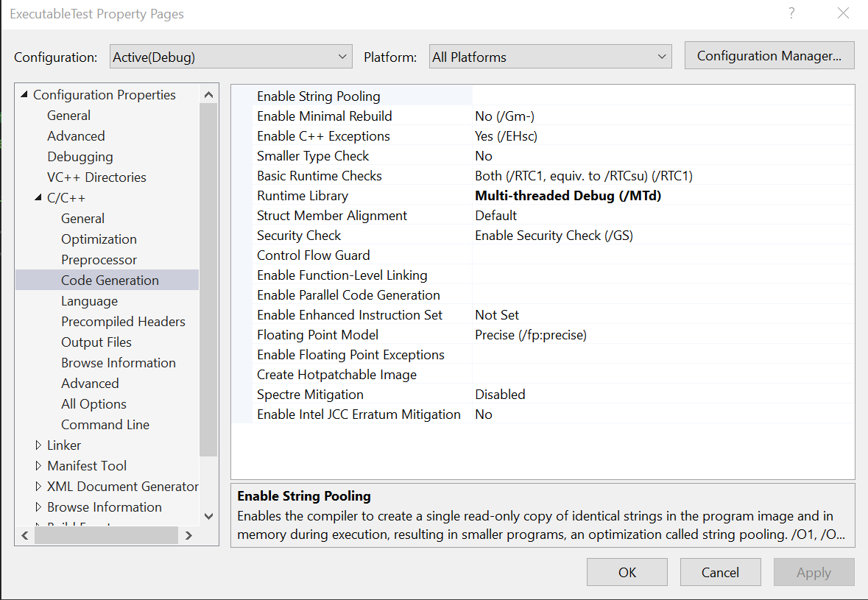

Using VS Community 2019 – Right click on your project file in the Solutions (IE: Solution Name: “Materia” Project file: “ExecutableTest” ). This will bring up the window above. Click on C/C++ and change the “Runtime Library” to “**Multi-threaded Debug (/MTd).** Apply the changes and build your project.

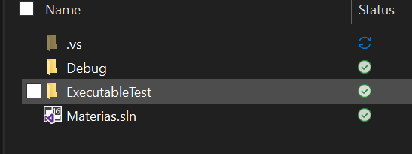

Next navigate to the solutions window of your project and navigate to debug. In there is your executable. Double click the executable and your program will run what you programed it to do.

